**I. Pen-and-paper**

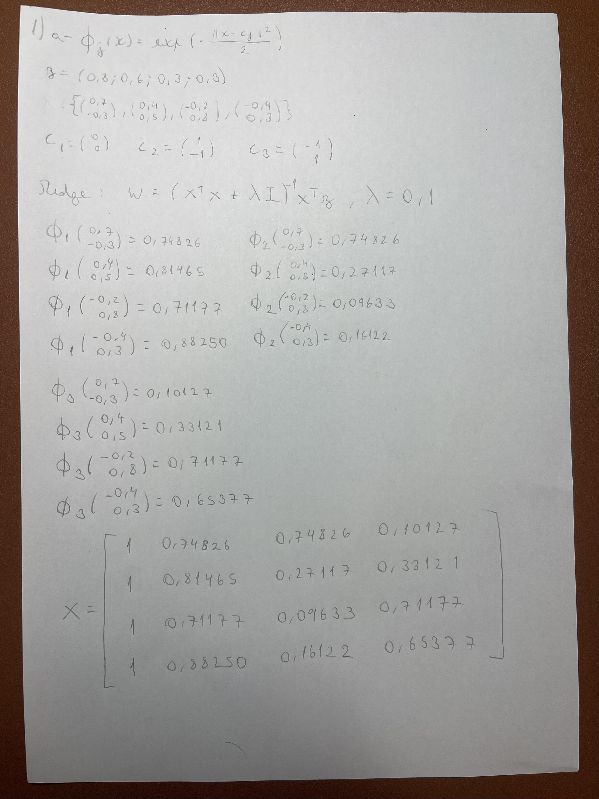

1)

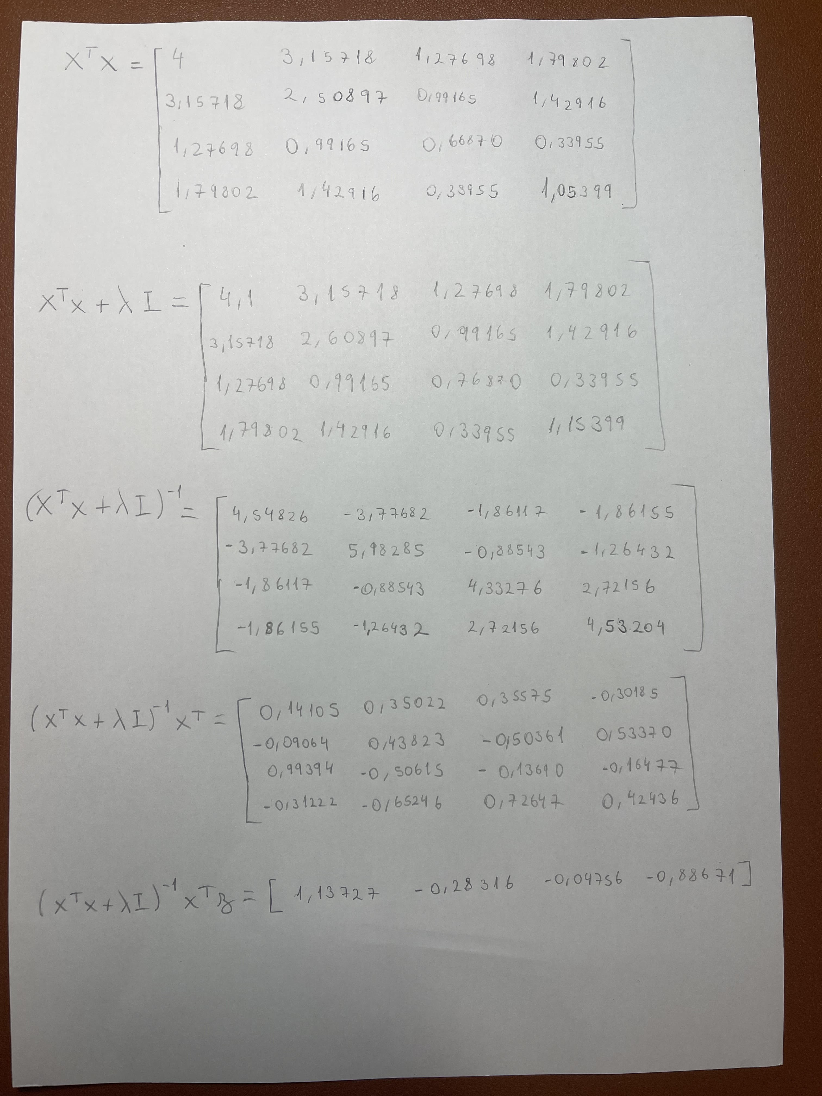

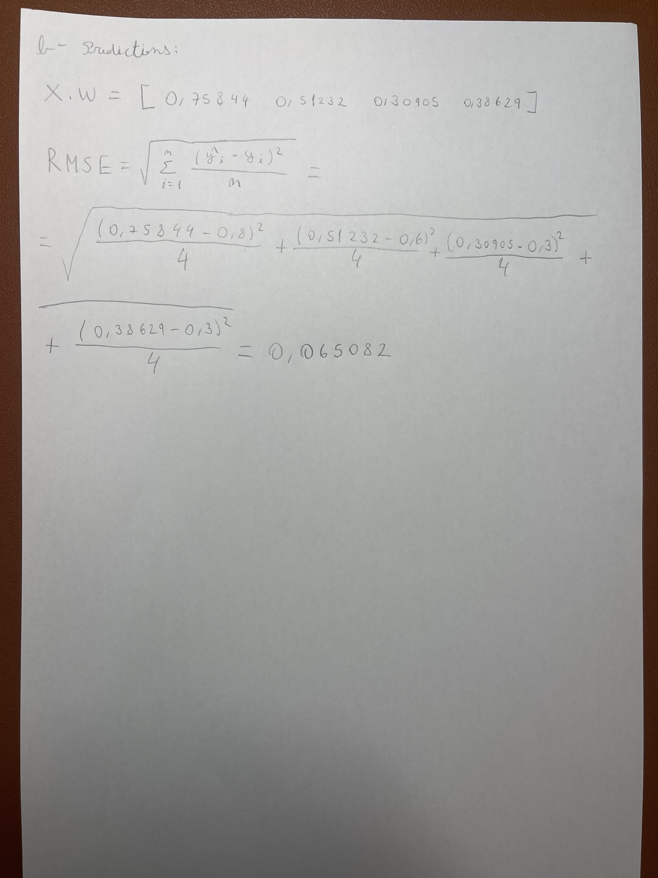

2)

**II. Programming and critical analysis**

1)

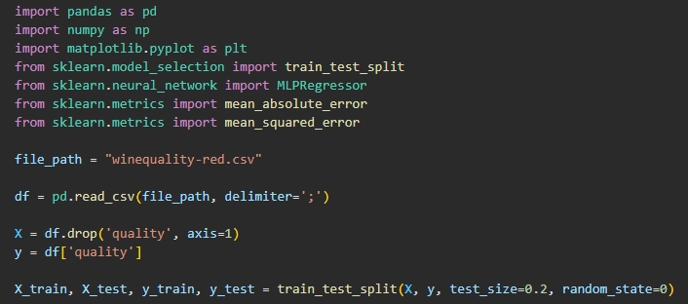

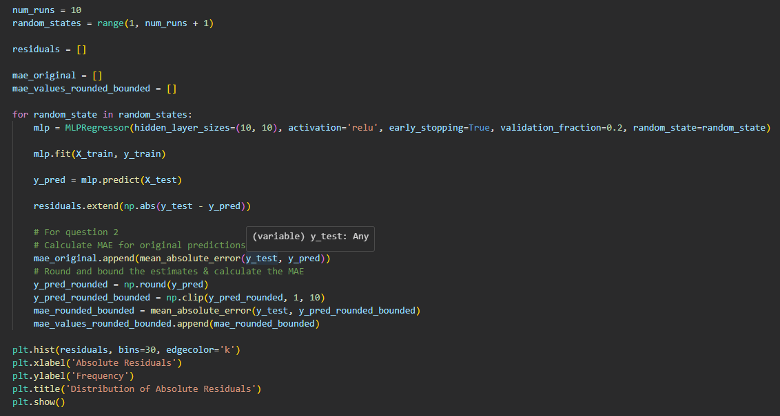

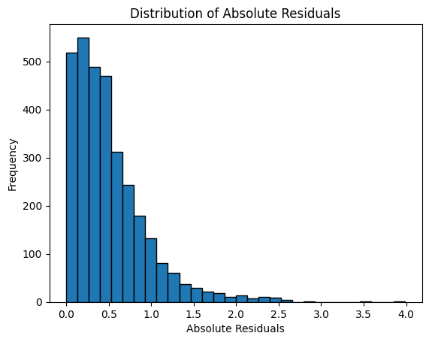

**2)**

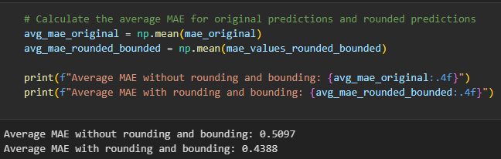

**3)**

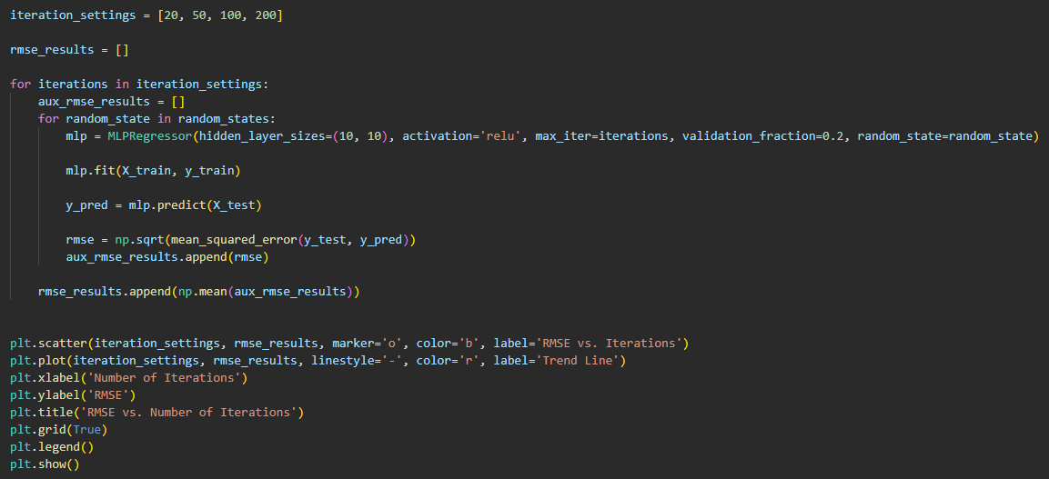

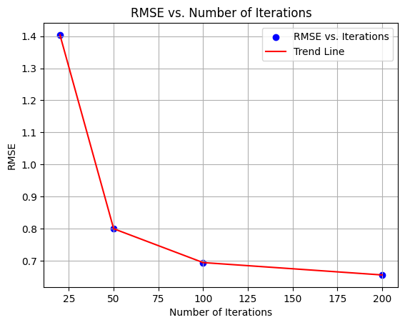

4) The results show a clear trend as the number of iterations increases, the RMSE generally decreases, indicating better model performance.

Early stopping helps prevent overfitting by stopping training when the validation error starts to increase, preventing the model from over-optimizing on the training data, leading to better generalization. It can also save trining time which is most relevant in bigger models.

On the other hand, early stopping can worsen performance when a model stops learning before it has converged to the optimal solution (global minimum of the loss function), particularly relevant if the chosen number of iterations is too small, leading to underfitting, where the model lacks the complexity to capture the underlying patterns in the data effectively. If the validation set is not representative of the test data or is too small, early stopping may also stop training prematurely or continue training unnecessarily, leading to suboptimal performance.

**END**